**Name: Nguyen Xuan Binh**

**Student ID: 887799**

**Fracture Mechanics Assignment 1**

We are given these data:



Using the given values, we can calculate the fracture toughness from the finite width plate formula from the datasheet (slide 5, second formula) as follows:



We have: 



The formula for fracture stress for infinite width plate from the datasheet (slide 3, 4th formula) is:

(answer)

The stress intensity factor for the edge crack according to the formula in the datasheet is:

 given the distance  from the crack tip. Integrate over distance b by the applied stress, we have:



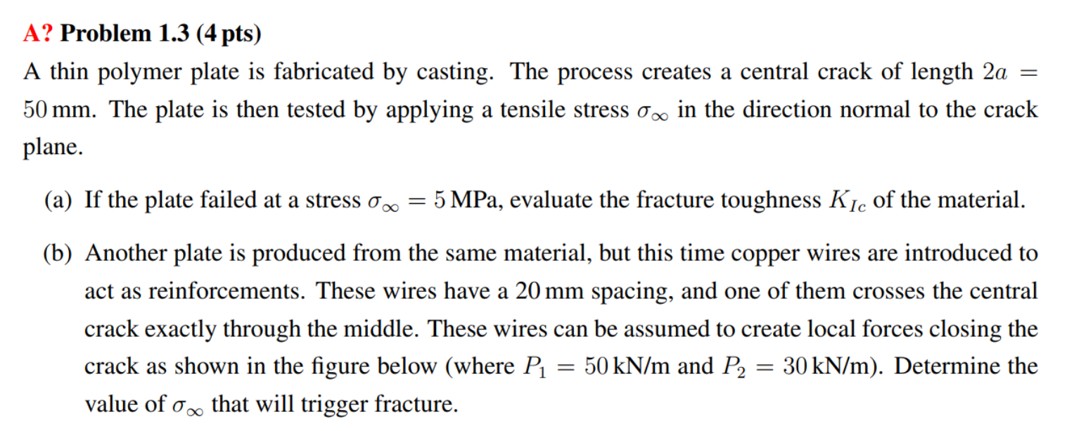

The fracture toughness of the material is

 (answer)

The stress intensity factor induced by P1 on the middle of the plate (at tip A formula in datasheet, slide 4). Note: the sign of P is negative because the wire is trying to close the gap



The stress intensity factor induced by P2 on the right side (at tip A formula in datasheet)



The stress intensity factor induced by P2 on the left side (at tip B formula in datasheet)



By principal of superposition, the fracture toughness with copper wires reinforcement becomes

The tensile stress that can triggers the fracture of the reinforced plate becomes

 (answer)

Adding the wires increases the fracture stress to 6.9 MPa